Al-Shabaab: History, Impacts, and Policy Implications

3/1/2026
Benjamin Verboncoeur
PS615-T301 Political Islam & Terrorism (2263-1)
Introduction
Harakat al-Shabaab al-Mujahideen, commonly known as Al-Shabaab, remains one of al-Qaeda's most enduring and lethal affiliates. It has dominated large swathes of rural Somalia since its emergence in the late 2000s. The group takes advantage of the fragility of the Somali state, clan divisions, and foreign interventions to pursue its Salafi-jihadist agenda. Its stated goals including kicking out "infidel" forces, overthrowing the government of Somalia, and imposing strict Islamic law throughout all ethnic Somali regions in eastern Africa.
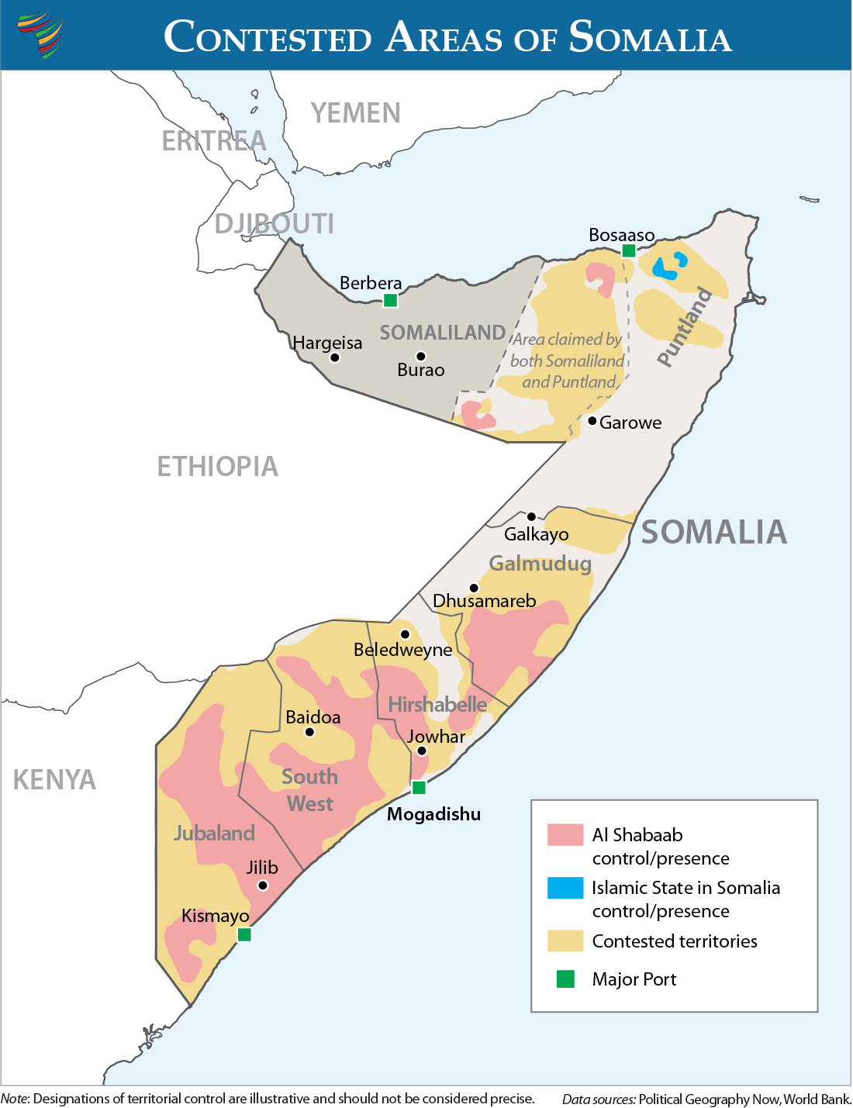
Al-Shabaab remains one of the most active terror groups in the world. They have accomplished this by conducting many major attacks (2013 Westgate Mall in Kenya, 2019 DusitD2 complex) and maintaining territorial control in southern and central Somalia. Despite back and forth conflicts the group has recently had success recapturing key areas in Middle and Lower Shabelle, Hiiraan, and near Mogadishu. This has destroyed any prior gains by opposition forces and allowed Al-Shabaab close access to the capital. Allowing them to attempt even a high-profile assassination attempt on Somali President Hassan Sheikh Mohamud in March 2025 and attacks on African stabilization forces.
Figure 1. Contested Areas of Somalia 2022.
As of February 2026, Al-Shabaab continues to thrive even under pressure from U.S. AFRICOM airstrikes, and joint operations attempting to reclaim villages (such as those lost in the Lower Shabelle). Despite the pressure, Al-Shabaab has been able to maintain revenue and recruiting through extortion, international remittances (such as the highly politicized Minnesota fraud), and online propaganda.
This paper will analyze Al-Shabaab's historical trajectory, it’s religious and philosophical base, existing policies from affected actors (Somalia’s FGS offensives, Kenya/Ethiopia border operations, U.S. strikes, African Union operations), and globalization's facilitation of transnational funding and radicalization. It will answer : "How have national and international policies addressed Al-Shabaab's persistent threat, and what adaptive changes are needed amid globalization and recent resurgence?"
History of Al-Shabaab
Harakat al-Shabaab al-Mujahideen (better known as al-Shabaab) originated in the late 2000s as the militant youth wing of the Islamic Courts Union (ICU). The ICU was a group of “sharia courts” that grew to prominence and even briefly controlled Mogadishu in 2006 (Cocodia, 2024). The group was then formed from hardline elements of the ICU and from even earlier Salafi groups like al-Ittihad al-Islami. Al-Shabaab served as the ICU's enforcement arm, imposing strict Islamic law amid Somalia's post-1991 state collapse and constant warlord conflicts. The group's prominence surged after Ethiopia's 2006-2009 invasion. Ethiopia a majority Christian nation invaded in an effort to stabilize and counter the ICU’s expansion at the request of Somalia's Transitional Federal Government(Cocodia, 2024). The occupation fueled recruiting efforts, enabling al-Shabaab to frame its resistance as defensive jihad against foreign "infidels." This attracted a large base of nationalist recruits willing to be radicalized by extremist ideology.
Using the Ethiopian invasion as fuel, al-Shabaab controlled large portions of southern and central Somalia by 2008. This included including parts of Mogadishu from 2008-2011, where it provided basic governance like policing while also using terrorism, IEDs, and assassinations against Ethiopian and African Union forces (AUSSOM). In February 2012, al-Shabaab pledged allegiance to al-Qaeda, aligning its local fight with global jihadism (Hansen, 2014). This shift emphasized transnational attacks, including the July 2010 Kampala bombings (76 killed), September 2013 Westgate Mall siege in Nairobi (67 killed), and eventually the January 2019 DusitD2 complex assault in Kenya (21 killed).
The transition from local resistance group to coherent international terrorist organization was not particularly smooth. In 2013, the then leader of al-Shabaab Ahmed Abdi Godane killed several of its own al-Shabaab members Ibrahim al-Afghani, and Maa’lim Hashi who had challenged his leadership (Hansen, 2014). Though the internal conflict revolved around control, ideology and leadership struggles, it effectively forced al-Shabaab into an international organization rather than local. It also solidified its philosophical stance as an organization. It allowed leadership to designate even other Muslim members of its own organization as Takfir. This further showcased their philosophy by allying with the teaching of Sayyid Qutb and Muhammad Ibn Abdul Al Wahhab. Godane was then killed soon after in September 2014 by a US airstrike. The next leader Ahmed Diriye (Abu Ubaidah) emphasized a religious ideological organization willing to label other Muslims as Takfir or part of the Jahiliyya (Bacon, 2022).
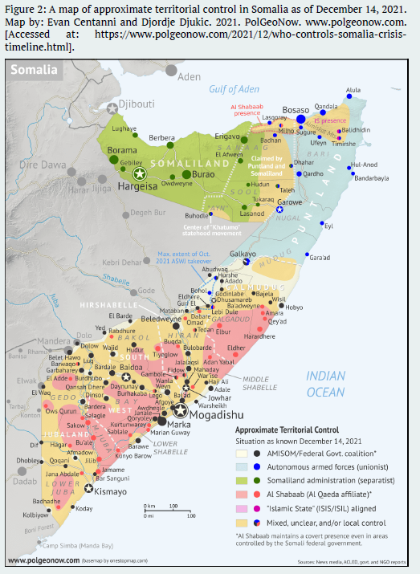
The strength and support for al-Shabaab grew tremendously after alignment with Al-Qaeda and the international Islamic terrorism scene. Though in Somalia, al-Shabaab has been in a constant dynamic state of conflict. In 2022-2023, the local Somali government lead an offensive, supported by clan militias (Ma'awisley) and U.S. airstrikes. They successfully seized several important areas in central Somalia (Williams, 2026). However just last year al-Shabaab's February 2025 conducted "Operation Ramadan" which completely reversed the gains, recapturing towns in Middle and Lower Shabelle. Several high-profile attacks followed shortly after including a March 2025 assassination attempt on Somali President Hassan Sheikh Mohamud via IED on his Mogadishu convoy. Then in May of 2025 they conducted a suicide bombing at a Somali government recruitment center, killing 21. Even now, al-Shabaab controls the outskirts of Mogadishu, threatening to retake the Somali capital (Williams, 2026).
Figure 2. Map of approximate territorial control of in Somalia as of December 2021.
Philosophical Roots
Al-Shabaab’s origins and endurance are tied to Somalia’s prolonged state collapse, clan fragmentation, Islamic extremism, and foreign military interventions. Abdi Shuriye locates the group’s ideological roots in Salafi movements external to Somalia. However, this influence finds a fertile ground in local hard-line elements following the 2006 Ethiopian invasion that toppled the Islamic Courts Union (ICU). This intervention fueled the Salafi a narrative of defensive jihad against “infidel” occupation from a primarily Christian nation (Shuriye, 2012). This allows Al-Shabaab to recruit using Islamic religious and philosophical pathways both inside and outside of Somalia. Similarly, Stig Hansen dig’s into Somalia’s history and divides it into five phases. Through the five phases he find’s key drivers of Al-Shabaab come from political fragmentation, warlordism, and the absence of effective justice systems feeding into a preexisting Islamic philosophy. The failed state situation feeds the narratives especially after the fall of Said Barre (in 1991) which made Sharia Law appear a better alternative.
Kfir doesn’t credit with Islam as a root cause but applies social identity theory to argue that human insecurity, social, economic, political, and civil factor’s are root causes. drives individuals toward groups offering certainty and belonging amid uncertainty. Anderson and McKnight extends this analysis to al-Shabaab groups in neighboring Kenya (Anderson and McKnight, 2015). They found how marginalization of Muslim communities in borderlands helped fueled the insurgency. Post takes it one step farther by linking examples of exclusions to justify violence against perceived out-groups (Post, 2018). This perspective places blame on the contexts of perceived injustice. Collectively, these works follow many different reasons for al-Shabaab to commit acts of terrorism. They generally exclude many popular views that al-Shabaab is purely a result of clan infighting but instead show a heavily studied complicated ideology that leads individuals towards terrorism.
The general literature around Al-Shabaab recruitment strategies tend to agree on their ideological appeal, material incentives, and social navigation within Somalia. Shuriye lay’s out the blueprint. Al-Shabaab often targets orphans and poor youth in Islamic institutions in efforts to go above clan lines (Shuriye, 2012). Others found that al-Shabaab use methods involving wages, free education, marriage incentives, and coercion. These methods also extending to women, children and diaspora from Kenya, Ethiopia, and beyond (Hassan, 2023). This would argue that they provide stability and structure in a nation lacking in either concept.
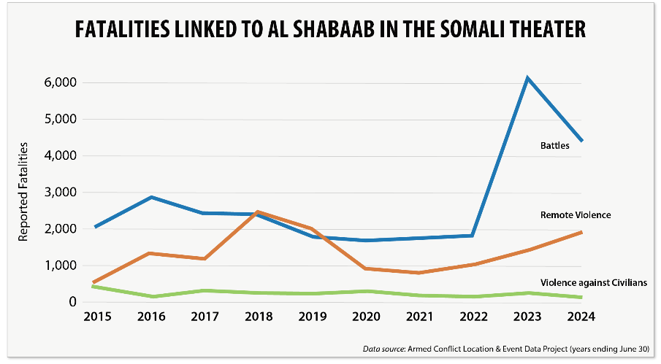
Christopher Anzalone’s work found that al-Shabaab runs a highly sophisticated media operations (including Swahili-language propaganda and films featuring East African ideologues) to attract regional recruits. This propaganda machine utilizes fundamentalist Islamic philosophies to frame attacks as responses to Muslim persecution (Anzalone, 2016). Kfir again looking through his application of the social identity theory argues that the group is specifically targeting marginalized individuals to find validation and purpose (Kfir, 2017). This aligns alongside many larger theories on terrorism such as Martha Crenshaw’s work The Causes of Terrorism (Crenshaw, 1981). Michael Skjelderup’s article takes a more minute view of their recruitment, arguing that they use a more diverse recruitment strategy at the clan level not just avoiding the clans like Shuriye argues (Skjelderup, 2020). Anderson and McKnight argues against that showing the organization’s adaptation in Kenya. Al-Shabaab in Kenya exploits ethnic Somali and non-Somali Muslim grievances, but moves beyond clan-centric recruitment to the wider Islamic world (Anderson and McKnight, 2015). This may by true in espoused rhetoric used by al-Shabaab however the majority of fighters that join al-Shabaab are from East Africa or diaspora. In the case of fighters joining from American, such as the 20 young boy’s from Minnesota, they were all from the Somali-American community (Biolcati, 2022).
Figure 3. Data Source: Armed Conflict Location & Event Data Project.
Al Shabaab Funding
Al-Shabaab is able to stay active for the last 20 years because of its highly effective financial system. This system is built from localized extortion, criminal business, and diaspora funding which has allowed them to adapt regardless of territorial gains/losses. Hassan provides the most detailed account, documenting systematic taxation (zakat on livestock and businesses, corporate/agricultural levies, transit fees) in area’s under al-Shabaab’s control, extortion from aid organizations, charcoal and sugar exports, piracy ransoms, and remittances via hawala networks (money transfers to third part individuals who act as a go-between). In total, it is estimated to generate $70–100 million annually (Hassan, 2013). Rob Wise’s work notes that they generate even more.
“Donations to al Shabaab are a portion of the larger diaspora remittances that send an estimated $1 billion a year to Somalia. As noted, the group has used the Internet to collect pledges from diaspora Somalis; in August 2009 it raised as much as $40,000 from members of the diaspora via an online fundraising forum. (Wise, 2011)”
This astounding number sounds made up but it comes from their ability to promote propaganda to wealthy Arab donor’s (especially with the groups linking to Al-Qaeda) and receive remittances from diaspora reportedly receiving US governmental assistance in Minnesota (Huyer, 2026). Generally, academia agrees on al-Shabaab’s unique ability to continue major streams of revenue despite territorial setbacks (Bryden, 2014). This provides a general understanding of al-Shabaab’s long term success and draw to young men.
Influences of Globalization
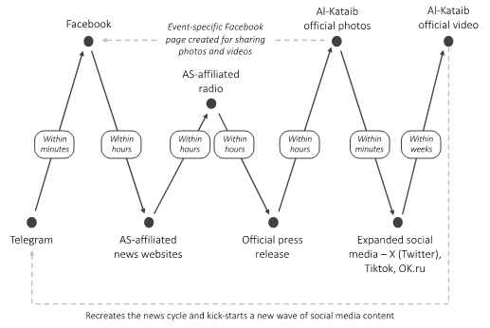
Globalization has successfully amplified Al-Shabaab’s reach through ideology diffusion, diaspora networks, and transnational alliances. The single largest detail is it’s deep Al-Qaeda ties for training, tactics, funding, and strategic direction (Shuriye, 2012). Anzalone describes regional media strategies targeting Swahili-speakers and cross-border attacks in Kenya to pressure troop-contributing countries (Anzalone, 2016). Kfir back’s this up as he emphasizes diaspora radicalization and global media amplifying grievances (Kfir, 2017). This is something seen on a greater scale with ISIS, Al-Qaeda and other Islamic terrorist organizations. The wider call fight’s within a preestablished religious and philosophical framework calling for defensive Jihad and the implementation of Sharia law in a justice system. The use of these concepts are not unfamiliar to every Muslim which is why it appeals so well to modern global terrorist groups. Post does a comparison of “exclusionary ideologies” with Boko Haram and al-Shabaab. He found that they both utilized global jihad rhetoric legitimizes local violence (Post, 2018). Globalization thus enables recruitment, funding and philosophical support to breed Islamic terrorism.
Figure 4. Al-Shabaab's Social Media Strategy (Gilroy, 2024)
Existing Policies Countering al-Shabaab
Counterterrorism policies against al-Shabaab involve international cooperation and strategies from Somalia, Kenya, Ethiopia, the United States and more. The policies typically focus on military efforts with a blend of diplomatic and economic measures. In Somalia, the local government has focused on military efforts to remove al-Shabaab (most successfully in their temporary campaign in 2022). Its clan sectionality is divided in its support but large clans like the Ma'awisley, helped expelled militants during the offensive. The loose structure of the government and lack of internal control and cohesion leads to many challenges from federal-clan tensions. For example, in northern Somalia, the state government’s strength and organization has led to Somaliland's de facto separation.
Kenya views al-Shabaab as a threat to border security and conducts enhanced patrols and surveillance to combat the growing influence of al-Shabaab in Kenya (Anderson and Mcknight, 2015). They have also participated in military incursions like Operation Linda Nchi in 2011. This was a joint operation which integrated Kenyan forces into the African Union Mission in Somalia (AMISOM) in an effort to support the Somali government and to disrupt Al-Shabaab's supply lines. They were successful in forcing al-Shabaab out of Kismayu. In response al-Shabaab resorted to cross-border terrorist attacks. Kenya has since included efforts at community engagement and intelligence-led operations but, Kenya has primarily utilized a military strategy against al-Shabaab (Anderson and Mcknight, 2015).
Ethiopia similarly has conducted direct military interventions, including the previously mentioned 2006-2009 invasion to counter the Islamic Courts Union. They were relatively successful seizing Mogadishu and forcing al-Shabab into the rural southern areas. The invasion however, sent many moderate Somalians into unity against an apparent foreign Christian military invading Somalia. Following their retreat, they ended up joining forces with Kenya, Uganda, Burundi Djibouti and Seirra Leone under AMISOM. This developed into ongoing support for Somali forces via training and joint operations with the current Somalian government. This security focused diplomacy, is now often in partnership with the US, aiming to neutralize threats along the shared Ethiopian-Somali border.
The United States has had a long history in Somalia since its attempts at providing aid to the Somalian population in the early 1990s post the Somalian civil war. Somalian resistance to the aid led to several clashes until the famous “Black Hawk Down” incident in 1993. Since then, direct involvement was limited until the US supported the Ethiopian invasion in 2006. By 2008, it designated Al-Shabaab a Foreign Terrorist Organization (FTO) enabling sanctions and asset freezes among al-Shabaab supporters in the United States. African Command (AFRICOM) has since conducted airstrikes and drone operations, targeting al-Shabaab leadership and camps. It has also provided training and advising towards Somali government forces.
The United States also has an estimated 260,000 Somalians living in the United States concentrated in Minneapolis (108,000 in the Twin Cities area). This has led to challenges of terrorism funding via hawala systems. Recent highly politicized fraud scandals have highlighted the risk. The Heritage Foundation found that local communities have been using 14 state welfare programs to fraudulently claim over $9 billion USD (Huyer, 2026). It is estimated that nearly 10% of that amount has been transmitted back to al-Shabaab via remittances. These policies highlight a US military focus but lack policies to remove funding and combat online recruitment efforts.
Impacts
Al-Shabaab has inflicted severe, multi-generational harm throughout the Horn of Africa and now even beyond. The group is responsible for thousands of deaths, estimates from the Global Terrorism Database from 2007-2023 place total fatalities (combatants and civilians) at approximately 9,500 terrorism related deaths (Andreescu, 2024). These are all through sustained insurgency, suicide bombings, and targeted assassinations. This does not include the effects of the instability along the border and within Somalia. Economically, Al-Shabaab has been disrupting trade by imposing extortion taxes on businesses, livestock, and aid convoys. This taxation burdens impoverished communities and deters investment from outside of Somalia.
Humanitarian consequences are also very evident. Al-Shabaab has repeatedly blocked food aid during crises, contributing to famine conditions for the local populace. In 2011, famine killed ~260,000 people, with Al-Shabaab restrictions clearly hindering efforts to help (Fitzpartrick, 2012). The conflict has additionally displaced over 3 million Somalis internally and driven hundreds of thousands into refugee camps in Kenya and Ethiopia. Al-Shabaab recruitment efforts towards the youth within Somalia has accelerated radicalization, while deepening sectarian tensions between.
Policy Changes
Somalia is a nation with a long history of conflict which will not be easily solved. The pathway towards peace and change comes from finding ways to reduce Al-Shabaab's recruitment and funding. The US, Somalia, Ethiopia, and Kenya should pursue a coordinated strategy emphasizing Somali-led initiatives and international support. This must include finding ways to strengthen internal Somali leadership. If the Somali government can address clan fragmentation and increase governance the appeal to join al-Shabaab will be reduced. Additionally, establishing programs that target youth via education, moderate Islamic scholars, and deradicalization efforts will reduce recruitment. This can be done both in Somali but also in major diaspora or remittance areas. This would both counter radicalization process and reduce the funding of the group which has allowed it to be as flexible and as successful as it has been.
From the international perspective, finding way’s to address poverty and famine through humanitarian aid, agricultural reforms, and economic development in partnership with the Somalia government will alleviate problems that fuel extremism. There must also be a disruption of diaspora funding channels by reducing fraud and adding restrictions on funding leaving the US. Prosecuting facilitators and monitoring other methods of fundraising will reduce al-Shabaab’s ability to sustain operations. Finally, the United States should encourage other more moderate Islamic nations, such as Jordan, Saudia Arabia or Egypt, to lead ideological and military interventions. This would reduce the recruitment effectiveness of defensive jihad against non-Muslim. If the rhetoric can be countered, the conflict will be reframing back into a regional conflict.
Conclusion
Somalian and international policies have attempted to address al-Shabaab's threat through military interventions including U.S. airstrikes, AUSSOM operations, and regional interventions. Yet, al-Shabaab has been highly adaptable fueling its military strength resurgence and globalized recruiting reach. Finding ways to cut its international funding and strengthen Somali leadership will reduce its viability as an organization. Addressing poverty and famine through foreign aid and economic initiatives will also help reduce their recruitment draw by mitigating problems that would draw Somalians to its ranks.
The United States need to rely on moderate Islamic nations to lead ideological campaigns against the "defensive jihad" narrative. Reducing direct US intervention will help battle the religious and philosophical arguments al-Shabaab uses. The US specifically needs and in-depth investigation into remittance funding from supporters within the Somalian diaspora community. Though this incident has been highly politicized, the possibility that Minnesota's welfare fraud scandals have potentially sent billions to Al-Shabaab would help counter its financial system. It highlights inadequate oversight of al-Shabaab’s financial network that sustains the group's despite military losses. Bridging these gaps through targeted intelligence and better community engagement is crucial for long-term regional stability.

References
Andreescu, Viviana. "Global Terrorism Index." In Encyclopedia of religious psychology and behavior, pp. 1-3. Cham: Springer Nature Switzerland, 2024.
Anderson, David M., and Jacob McKnight. "Understanding al-Shabaab: clan, Islam and insurgency in Kenya." Journal of Eastern African Studies 9, no. 3 (2015): 536-557.
Anzalone, Christopher. "The resilience of al-Shabaab." CTC Sentinel 9, no. 4 (2016): 13-20.
Afriyie, Frederick Appiah. "What fuels terrorism in Somalia? Perspectives from the jihadist group Al-Shabaab." Cogent Social Sciences 11, no. 1 (2025): 2576151.
Bacon, Tricia. "Inside the minds of Somalia’s ascendant insurgents: An identity, mind, emotions and perceptions analysis of al-Shabaab." Program on Extremism. George Washington University (2022).
Biolcati, Camilla. "FOREIGN FIGHTERS OF AL-SHABAAB: SOMALI-AMERICAN COMMUNITY IN MINNESOTA CASE STUDY." THE POLICY OF NATIONAL SECURITY: 47. (2022).
Bryden, Matt. "The reinvention of al-Shabaab." Center for Strategic & International Studies 12 (2014).
Cocodia, Jude. "Rejecting African solutions to African problems: The African union and the Islamic courts union in Somalia." African Security 14, no. 2 (2021): 110-131.
Crenshaw, Martha. "The causes of terrorism." Comparative politics 13, no. 4 (1981): 379-399.
Gilroy, Georgi. "The Online Frontline: Decoding al-Shabaab’s Social Media Strategy’." CTC Sentinel 17, no. 1 (2024): 25-30.
Hansen, Stig Jarle. Al-Shabaab in Somalia: The history and ideology of a militant Islamist group. Oxford University Press, 2013.
Hassan, Mohamed Rage. "Unveiling Al-Shabaab: A Comprehensive analysis of evolution and influence." International Journal of Scientific Engineering and Research 11 (2023): 25-29.
Huyer, Nicole. “Somali Welfare Fraud in Minnesota Has Cost American Taxpayers billions.” The Heritage Foundation. (2026). https://www.heritage.org/welfare/commentary/somali-welfare-fraud-minnesota-has-cost-american-taxpayers-billions
Kfir, Isaac. "Al-Shabaab, social identity group, human (in) security, and counterterrorism." Studies in Conflict & Terrorism 40, no. 9 (2017): 772-789.
Odhiambo, Elijah Onyango Standslause, Everlyne Wanjiru Njoroge, and Mohammed M. Hafez. "Al-Shabaab’s Financial Fortitude: The Link between Funding Strategies and Organizational Resiliency." (2025).
Post, Gerdine. "Justifying the Unforgivable: how ideology shapes patterns of violence of Boko Haram and Al-Shabaab." (2018).
Shuriye, Abdi O. "Al-Shabaab’s leadership hierarchy and its Ideology." Academic Research International 2, no. 1 (2012): 274-285.
Skjelderup, Michael Weddegjerde. "Jihadi governance and traditional authority structures: al-Shabaab and Clan Elders in Southern Somalia, 2008-2012." Small Wars & Insurgencies 31, no. 6 (2020): 1174-1195.
Williams, Paul D. "Conventional Insurgents: Understanding al-Shabaab’s Mass Attacks against African Union Bases in Somalia." Studies in Conflict & Terrorism 49, no. 2 (2026): 161-183.
Wise, Rob. al Shabaab. Washington DC: Center for Strategic and International Studies, 2011.

