Environmental Degradation and Eco-Conflict Risk in Southeast Asia: A Comparative Analysis of Indonesia and Vietnam

Benjamin Verboncoeur
PS605-T301 Green Security: Eco-conflict (2261-1)
November 16, 2025

Introduction
Southeast Asia stands at the edge of climate-induced environmental risks, where environmental degradation intersects with population pressures, resource scarcity, and geopolitical tensions. This paper analyzes eco-conflict vulnerabilities in Indonesia and Vietnam, two nations facing shared yet distinct challenges from population density, persistent poverty, resource depletion, and accelerating climate impacts. While both countries exhibit high exposure to environmental stressors that amplify internal unrest and transboundary disputes, Vietnam faces a more acute interstate eco-conflict risk due to upstream Mekong River dependencies, whereas Indonesia's vulnerabilities lean toward internal displacement and regional diplomatic friction. Without increased regional cooperation, these pressures could escalate into significant state fragility, migration-driven tensions, and resource conflicts by mid-century.
The analysis draws on four interconnected domains, population, poverty, resources, and environment, revealing that Indonesia's archipelagic scale and palm oil-driven deforestation create conflicts but manageable internal risks. Contrast that with Vietnam's Mekong Delta vulnerabilities that heighten dependence on upstream actors like China and Laos. Both combine with regional conflicting claims over valuable South China Sea fishing and oil grounds. Scholarly evidence underscores how climate change acts as a threat multiplier, potentially displacing millions (up to 10 million in Vietnam's delta alone if sea-levels rise) and fueling competition over fisheries, water, and land. Recent policy responses, including Just Energy Transition Partnerships (JETPs), offer promising frameworks for mitigation, yet lack of funding and strong governance continue. Ultimately, the findings indicate moderate-to-high eco-conflict potential by 2050 (if current trends continue) emphasizing the urgent need for transboundary diplomacy and inclusive resilience strategies to avert escalation.
Indonesia
Population
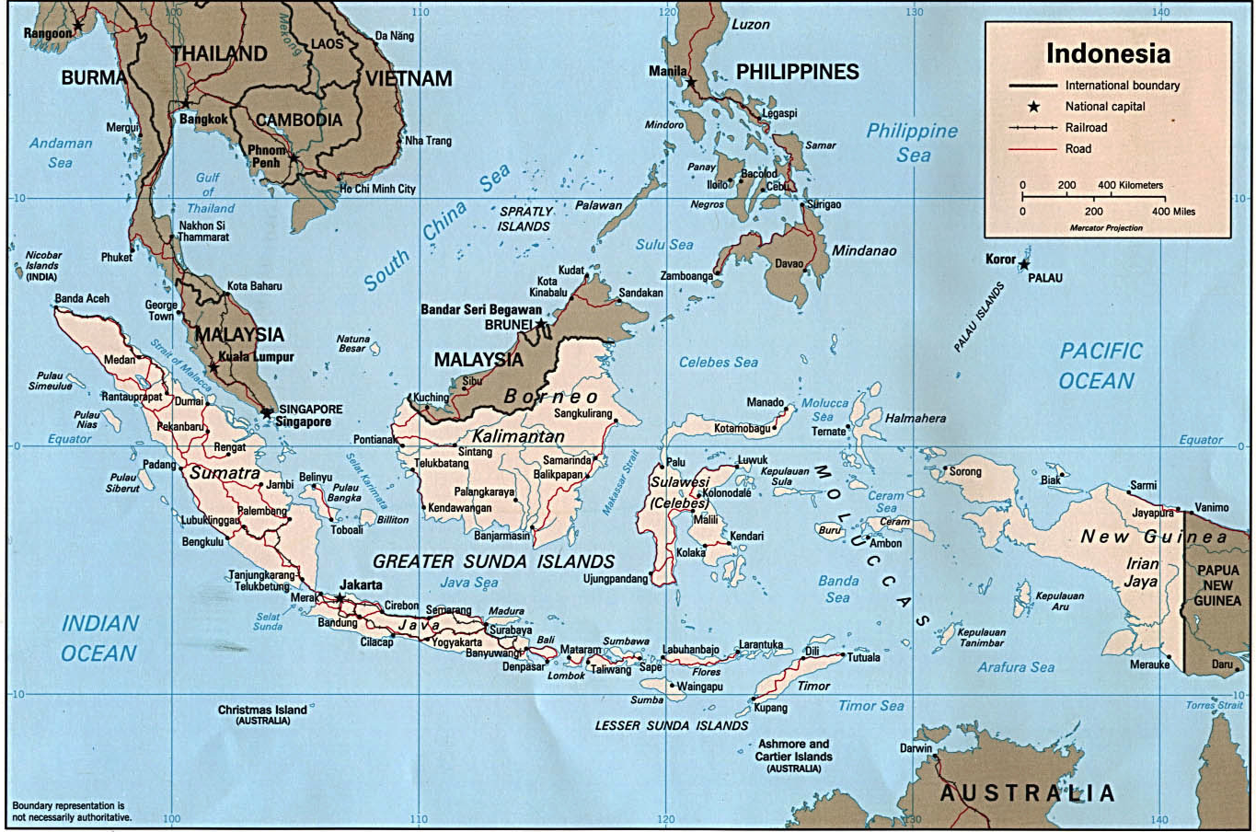
Indonesia, with a population of over 270 million, is the world’s fourth most populous country, with high density in urban centers like Jakarta, where 15,000 people per square kilometer strain infrastructure (World Bank 2023). Rapid urbanization, with 57% of the population urban by 2023, amplifies pressure on housing and services, increasing risks of social unrest (Do Miswa and Kartiasih, 2025) Coastal areas, home to 60% of Indonesians, face climate-induced displacement from rising sea levels, potentially displacing millions and sparking conflicts over land with neighboring provinces or countries like Malaysia (Gan et al. 2021). Overcrowding in Java, where 56% of the population resides on 7% of the land, could drive migration to less populated islands, raising tensions over resource allocation (Oktari et al. 2022). This could cause significant internal conflict as there is still plenty of undeveloped land on other islands but it would cause significant problems moving vast numbers to other islands.
Poverty
Indonesia has reduced poverty from 19.1% in 1999 to 9.36% in 2023, yet 24 million remain below the national poverty line, and 60.3% are poor by the World Bank’s upper-middle-income threshold of $6.85/day (World Bank, 2023). Rural communities, dependent on agriculture, face heightened risks from climate shocks like floods, which disrupt livelihoods and deepen poverty (Do Miswa and Kartiasih, 2025). This vulnerability could fuel local conflicts over land and water, potentially escalating to regional disputes if displaced populations migrate to urban centers or neighboring countries (Rahmawati and Purnomo 2023). High inequality additionally exacerbates tensions, as wealthier groups benefit disproportionately from resource exploitation from some of Indonesia’s vast resources.
Resources
Indonesia’s fisheries and forests face depletion from overexploitation and climate impacts. Fisheries, contributing $26.9 billion annually, have declined 4% since 2017 due to overfishing, threatening food security for 50% of the population reliant on fish (Climate Impacts Tracker, 2024). Deforestation, significantly driven by palm oil plantations, has caused 10% forest loss since 2001, creating transboundary haze issues with Malaysia and Singapore, which have already sparked a rise in diplomatic tensions (Atkinson, 2021). Competition for dwindling forest and fishing resources could escalate into regional conflicts, especially over maritime boundaries in the South China Sea, where Indonesia’s claims overlap with neighbors including Vietnam and China (Puspitawati and Hidayat 2022).
Environment
Indonesia’s environmental vulnerability stems from frequent hydrometeorological disasters, with 78% of events from 2005 to 2019 being floods or fires (Oktari et al. 2022). Forest fires, linked to palm oil expansion, caused $16 billion in losses in 2015 and contribute to regional haze, straining relations with Malaysia (Atkinson, 2021). Sea-level rise could threaten 25% of Jakarta, potentially displacing millions and increasing cross-border migration pressures (Birkmann, et. al, 2022). These environmental stressors could heighten tensions with neighbors if resource competition or refugee flows intensify. Additionally, Indonesia has 84 active volcanos with massive potential to dramatically alter the environment at any time (Oppenheimer, 2003, 251).
Vietnam
Population
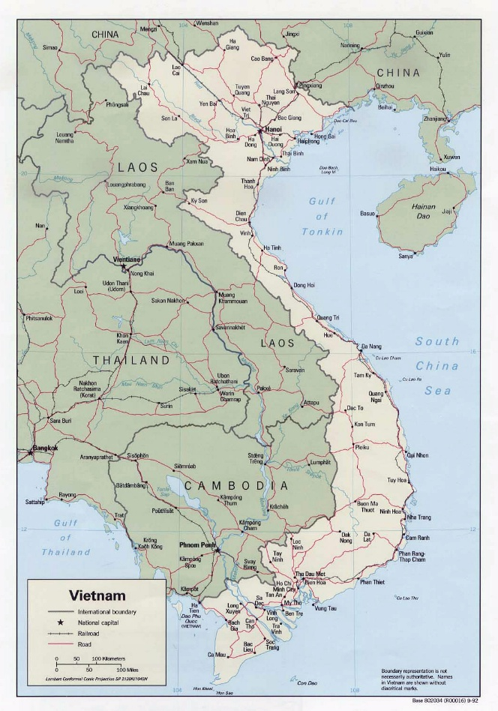
Vietnam’s population of 100 million is heavily concentrated in the Mekong Delta and coastal areas, with 37% urbanized by 2023 (World Bank 2023). High density in the delta, producing 50% of the nation’s rice, faces risks from flooding and salinization, which could potentially displacing 10 million people by 2050 if waters rise (Tran et al. 2023). This could drive migration to Cambodia or Thailand, raising tensions over border resources (Nguyen et al. 2023). Urban overcrowding in Ho Chi Minh City, with 4,300 people per square kilometer, strains infrastructure, potentially fueling social unrest if services collapse (Le et al. 2019). Vietnam has the benefit of no overwhelming populace in a high-density area (in comparison to Indonesia) but the population focus around areas easily affected by climate change could cause future conflict.
Poverty
Vietnam’s poverty rate dropped from 70% in the 1990s to 4.2% in 2020, which shows major progress, but rural and ethnic minority communities remain vulnerable, with 20% of ethnic groups below the poverty line (Vo, 2018). Climate shocks, such as droughts affecting 60% of rural livelihoods, deepen poverty and food insecurity, potentially sparking local conflicts over land (Birkmann, 2022). Migration to urban centers or neighboring countries could escalate tensions, particularly with Cambodia, if resource competition intensifies (Hoang et al. 2022).
Resources
The Mekong River, vital for 60% of Vietnam’s food production, faces reduced flow from upstream dams in China and Laos, causing salinization and a 15% drop in fish stocks since 2000 (Tran, 2023). This threatens livelihoods for 10 million people, potentially leading to competition with Cambodia over shared fisheries (Nguyen and Vu 2021). Water scarcity, exacerbated by upstream damming, could spark interstate disputes if transboundary agreements remain absent (Birkmann, 2022).
Environment
Vietnam ranks among the top five countries vulnerable to climate change, with 70% of its population exposed to flooding and heatwaves (Birkmann, et. al, 2022). CO2 emissions doubled from 1980 to 2005 due to industrialization, degrading air and water quality (Le et al. 2019). Heat-related mortality could increase 26% by 2090, straining healthcare systems and potentially causing social unrest (Nguyen et al. 2023). The Mekong River is the largest environmental stressor in Vietnam. It starts in China and travels through Laos which causes issues, driven by upstream damming, that could cause conflict if environmental degradation continues unchecked (Tran et al. 2023).
Potential for Eco-Conflict
Both Indonesia and Vietnam face significant eco-conflict risks due to population pressures, poverty, resource scarcity, and environmental degradation. In Indonesia, internal displacement from sinking cities and deforestation-related tensions could spill over regionally, particularly with Malaysia over haze or maritime disputes. In Vietnam, Mekong River disputes with China and Laos pose a high risk of interstate conflict, exacerbated by population displacement and resource competition. Both nations require robust adaptation strategies and regional cooperation to mitigate these risks.
Review of Scholarly Claims:
This analysis examines eco-conflict vulnerabilities in Indonesia and Vietnam across four key risk categories: population, poverty, resources, and environment, as critical drivers of potential regional or interstate conflicts in Southeast Asia. For each category the scholarly assertions will be examined in the contexts of the two nations, highlighting how these vulnerabilities intersect with climate pressures, resource competition, and geopolitical tensions. Similarities across the two nations include shared exposure to climate-induced stressors amplifying internal displacements and transboundary disputes, while differences emerge in scale (e.g., Indonesia's vast archipelagic geography versus Vietnam's delta-centric vulnerabilities) and socio-economic trajectories (e.g., Indonesia's persistent inequality versus Vietnam's rapid poverty reduction). The analysis shows that the environmental vulnerabilities signal heightened eco-conflict risks, which needs a proactive government willing to avert escalation.
Population: Pressures from Density, Urbanization, and Climate Displacement
Metric | Indonesia | Vietnam
Total Population (2023) | 270+ million | 100 million
% Urbanized (2023) | 57% | 37%
Highest Urban Density | 15,00/km² (Jakarta) | 4,300/km² (Ho Chi Minh City)
% Population in Coastal/Delta Areas | 60% | 70%
Projected Climate Displacement by 2050 | Millions (coastal + Java) | 10 million (Mekong Delta)

Population remains an extreme eco-conflict vulnerability emphasize for both nations. Demographic concentrations exacerbate resource strains and displacement risks, particularly in climate-vulnerable coastal and delta regions where most of the population either lives or benefits from resources from. In Indonesia, the World Bank (2023) documents a population exceeding 270 million, with 57% urbanized by 2023 and densities reaching 15,000 per square kilometer in Jakarta. This strains infrastructure and amplifies social unrest amid climate shocks (Do Miswa and Kartiasih 2025). Coastal populations, comprising 60% of the total, face displacement from sea-level rise, potentially affecting millions and igniting land conflicts with neighbors like Malaysia (Gan, 2021). Rina Oktari extended this, noting Java's overcrowding, 56% of the population on 7% of land, drives inter-island migration, heightening tensions over undeveloped resources despite available land (Oktari, 2022). This internal migration could evolve into regional disputes if unchecked, as population growth intersects with environmental degradation to erode adaptive capacities (Birkmann, 2022).
In Vietnam, analogous pressures manifest in the Mekong Delta, home to 100 million people with 37% urbanization by 2023, where densities in rice-producing areas threaten 15 million displacements due to sea level rise and salinization (Tran, 2023; World Bank 2023). This concentration, unlike Indonesia's dispersed archipelagic densities, risks cross-border migration to Cambodia or Thailand, straining shared border resources (Gan, 2021). Additionally, urban centers like Ho Chi Minh City's have 4,300 people per square kilometer, where environmental impacts could risk infrastructure collapse. Vietnam doesn’t present the same level of risk as compared to Indonesia's Java. Additionally, ethnic minorities in rural deltas face disproportionate vulnerabilities, linking population focus to potential conflict over arable land (Vo, 2018).
Both nations have many similarities, including their coastal/delta concentrations of population, 60% in Indonesia, 70% in Vietnam. This means significant portions of the population are highly exposed to hydrometeorological disasters, per (Gan, 2021) and (Tran, 2023). Any increases in "threat multipliers" like displacement and resource competition could spill into interstate tensions (Birkmann, 2022) with any number of surrounding nations. Do Miswa and Kartiasih (2025) and Nguyen, (2023) concur that urbanization accelerates this, with climate shocks displacing millions and eroding social cohesion. Differences lie in geographic scale: Indonesia's archipelago enables internal migration to less dense islands, but this does increase the risk of internal ethnic conflicts (Oktari, 2022). Vietnam's linear delta reliance heightens transboundary frictions with upstream actors like China (Le, 2019). Overall, scholars like Joern Birkmann (2022) assert that without a wider spread in the population, environmental pressures could lead to eco-conflicts.
Poverty: Socio-Economic Vulnerabilities and Conflict Amplification
Metric | Indonesia | Vietnam
National Poverty Rate | 9.36% (2023) | 4.2% (2020)
Population Below Poverty Line | 24 million | 4. 4 million

As seen in a wide variety of literature, poverty can be a conduit for conflict. Jonathan Goodhand in his work “Violent conflict, poverty and chronic poverty” argues that while poverty by itself is unlikely to lead to conflict due to the poor’s Inability to voice its concerns but horizontal inequalities especially when coincided with identities or boundaries may increase the likelihood of conflict (Goodhand, 2001). In Indonesia, poverty has declined to 9.36% nationally by 2023, yet 24 million remain below the line, with 60.3% vulnerable at the $6.85/day threshold (World Bank 2023). Rural agricultural communities, (Do Miswa, 2025), endure floods that disrupt incomes, fueling land-water conflicts that may escalate regionally via urban migration (Rahmawati and Purnomo, 2023). Inequality exacerbates this, as resource exploitation benefits elites, marginalizing the poor (Purwono, 2021). Birkmann argues that climate variability traps the poor in cycles of vulnerability, with ethnic minorities facing heightened risks from deforestation and haze, potentially sparking unrest.
Vietnam's trajectory shows steeper poverty reduction, from 70% in the 1990s to 4.2% in 2020, but rural ethnic groups persist at a 20% poverty rate (Vo 2018). Especially when dealing with droughts as they affect 60% of rural livelihoods. Droughts deepening food insecurity and local land conflicts, with migration to Cambodia threatening interstate tensions (Hoang, 2022). Unlike Indonesia's broader inequality, Vietnam's vulnerabilities cluster among minorities, where climate issues compound ethnic marginalization (Tran, 2023). Though not as much of a pressing issue as water issues in the Mekong Delta, industrialization's environmental toll indirectly sustains poverty by degrading air and water, straining healthcare for the poor.
Both Indonesia and Vietnam have a heavy influence from poverty in its population, and it showcases itself as a "vulnerability amplifier," where climate disasters disproportionately burden low-income groups (Birkmann (2022). This could lead to potential migration-induced conflicts in both nations. Rahmawati and Purnomo (2023) highlight rural-urban flows as common pathways to escalation, with ethnic dimensions in both contexts. Differences appear in lasting tensions: Indonesia's higher baseline (9.36% vs. Vietnam's 4.2%) sustains broader inequality-driven tensions (World Bank 2023), while Vietnam's rapid gains mask delta-specific ethnic poverty traps (Hoang, 2022). Birkmann warns that without targeted adaptations, poverty will catalyze eco-conflicts, aligning with the paper's emphasis on resource disputes.
Resources: Depletion, Competition, and Transboundary Tensions
Resource | Indonesia | Vietnam
Fisheries Economic Value | $26.9 billion/year | Not reported (but 60% of food production from Mekong)
Fisheries Decline since Baseline | 4% since 2017 | 15% since 2000
%population Reliant on Fish | 135+ million | 10 million
Transboundary Resource Conflict | Haze (Malaysia, Singapore) | Upstream damming (China, Laos)

Scholarship on resources underscores depletion in fisheries and forests as flashpoints for conflict, driven by overexploitation and climate variability. In Indonesia, fisheries, yielding $26.9 billion annually, have declined 4% since 2017, threatening food security for 50% of the population (Climate Impacts Tracker 2024). Deforestation for palm oil has erased 10% of forests since 2001, generating haze that strains relations with Malaysia and Singapore (Atkinson 2021). South China Sea claims overlap between Vietnam, Indonesia, Brunei and China which further heightens maritime disputes (Puspitawati and Hidayat, 2022). Overfishing fuels "fish wars" among users (Oktari, 2022). leading to broader scarcity, where competition erodes livelihoods and invites interstate friction.
Vietnam's Mekong River sustains 60% of food production but faces 15% fish stock drops since 2000 from upstream dams in China and Laos, salinizing waters and endangering 10 million livelihoods (Tran, 2023). Nguyen and Vu (2021) argue this scarcity sparks fisheries rivalries with Cambodia, absent transboundary pacts. Unlike Indonesia's marine focus, Vietnam's riverine dependencies amplify damming conflicts, per Tuan and Chinvanno (2011), potentially escalating to interstate crises if flows diminish further.
Commonalities between the nations include resource depletion as a "conflict multiplier," with declines in fisheries (4% in Indonesia, 15% in Vietnam) driving competition (Climate Impacts Tracker 2024; Tran 2023). International boundary issues with the South China Sea (both), haze (in Indonesia) and damming (Vietnam) straining relationships with their neighbors (Atkinson 2021; Nguyen and Vu 2021). Both nations' overlap in the South China Sea underscore larger geopolitical risks (Puspitawati and Hidayat 2022) especially in relation to larger regional threats such as China. There are some major differences. Indonesia's forests-fisheries dual crisis involves regional haze diplomacy (Atkinson 2021), while Vietnam's Mekong-centric scarcity targets upstream hydro-hegemons (Birkmann 2022).
Environment: Degradation, Disasters, and Interstate Ramifications
Environmental Stressor | Indonesia | Vietnam
Disaster Type | Floods & Fires | Flood
Sea-Level Rise impact | 25% | 15%
Unique Hazard | 84 active volcanoes | Mekong Delta Flooding

Both nations are facing extreme degradation and natural disasters that can operate as existential threats, compounding vulnerabilities and fostering conflicts. In Indonesia, 78% of 2005-2019 disasters were floods or fires, with 2015 blazes costing $16 billion and haze provoking Malaysian tensions (Oktari, 2022; Atkinson 2021). Sea-level rise endangers 25% of Jakarta, displacing millions along the coastlines and pressuring certain borders (Birkmann, 2022). Additionally, Indonesia deals with 84 active volcanoes as wildcard disruptors that can exacerbate haze problems in addition to the threat of mass destruction. Additionally, palm oil fires degrade ecosystems (Do Miswa and Kartiasih, 2025), harming the economy.
Vietnam ranks near the top of the world in climate vulnerability, with 70% of its population flood-exposed and CO2 emissions doubling from 1980 to 2005 from industrialization (Birkmann, 2022; Le, 2019). Heat mortality may also rise to as much as 26% by 2090 if temperatures continue to rise (Nguyen, 2023). The already heavily mentioned Mekong damming drives economic degradation (Tran, 2023). Unlike Indonesia's volcanic-multi-hazard profile, Vietnam's stressors center on riverine or coastal flooding, amplified by climate change and upstream conflicts.
Overlaps: Both face hydrometeorological dominance (78% in Indonesia, 70% exposure in Vietnam), with environmental disasters like floods and over fishing fueling transboundary disputes. Contrasts: Indonesia's fires/volcanoes provide a unique problem that will require disaster response efforts to prioritize those in danger versus Vietnam's linear Mekong risks interstate conflict.
Indonesian and Vietnamese Policy Responses and Risk Evaluation
Vietnam and Indonesia, as archipelagic Southeast Asian nations, confront profound environmental risks from climate change, including sea-level rise, extreme weather, deforestation, and biodiversity loss. Vietnam's vulnerabilities center on the Mekong Delta's salinization and flooding, threatening rice production and livelihoods for millions, while Indonesia faces fires, volcanoes, transboundary haze, and forest degradation in biodiversity hotspots like Borneo and Sumatra. Both countries have escalated responses through national policies emphasizing mitigation and adaptation, international commitments under the Paris Agreement, and partnerships with non-governmental organizations (NGOs). These efforts show a careful balance of priorities (Vietnam's rapid industrialization and Indonesia's resource exports). Implementation gaps persist due to funding shortages, governance challenges, and civil society restrictions.
Vietnam's national response is anchored in international agreements such as the Paris Climate accords. At a smaller level it has approved the latest revision of the Power Development Plan VIII (PDP8), in April 2025. This plan marks a plan for change by building 6GW of offshore wind power by 2030, though its wind power may be implausible to implement without an identified investor or legal framework (Ha-Duong, 2025). Vietnam has also implementation of the Just Energy Transition Partnership (JETP) which should result int 47% of electricity being renewable by 2030, reintroducing international partnerships for nuclear power, and adding 99.9 GW of capacity, including solar, wind, and hydro-pumped storage. This also means abandoning coal projects to protect renewable energy goals in order to secure 15.5 billion from the G+7 (Ha-Duong, 2025).
Complementary policies for Vietnam include the 2014 Law on Environmental Protection, the Law of the Sea of Vietnam 2012, the National Action Plan on Air Quality Management (2021-2025), the Methane Emissions Reduction Action Plan, and many more in protection of specific resources (Giang, 2024). Many of these plans and laws focus on resilient resources and agriculture via state protection and climate-smart practices like water and nutrient-smart technologies. Internationally, Vietnam's updated Nationally Determined Contribution (NDC, 2022) commits to 15.8% unconditional and 43.5% conditional GHG (Green House Gasses) reductions by 2030 (Qiu, 2024). Vietnam has made progress and popular opinion within Vietnam is that the government is taking climate change seriously (Qiu, 2024) including limited risks to communities already in danger of extreme weather events being vulnerable to hydropower proposals in JETP projects.
NGOs operate under Vietnam's restrictive civil society environment, which does face activist arrests. Domestic groups like GreenID advocate clean energy (though its leader was arrested in 2022 for tax evasion) and the Centre for Sustainable Development Studies monitors pollution (Altman, 2024). They were able to take place in Climate Change Working Groups (CCWG) in 2008 but otherwise NGO involvement has been minimal or restricted by the Communist Party of Vietnam (CPV). International NGOs such as WWF and UNDP support JETP and adaptation as they help monitor success levels for foreign funding (Altman, 2024)..
Indonesia's framework revolves around the principles established by the United Nations in the UN Framework Convention on Climate Change (UNFCCC). Long-Term Strategy for Low Carbon and Climate Resilience (LTS-LCCR) 2050, targeting net-zero by 2060 or sooner (Tarigan, 2025). The Forestry and Other Land Use (FOLU) Net Sink 2030 seeks net-negative emissions via peat restoration and moratoriums on primary forests (Simorangkir, 2024). Additional policies include a delayed carbon tax (2025), Emissions Trading System, and Presidential Regulation 110/2025 on carbon pricing (Sunanda, 2025). Internationally, the enhanced NDC sets unconditional CO² reductions at 31-34% and conditional at 41-45% by 2030. The JETP provides international aid (USD 20 billion) to cap power emissions and target 44% renewable energy by 2030 (Juzuli, 2024). Though arguments are made against the effective ness of the REDD+ program in Indonesia, it has delivered USD 499.8 million in payments, with 2025 gains of USD 340.7 million (Gatto, 2025). Challenges for these programs include weak coordination, bad governance, inferior institutional quality and prioritization of mitigation over adaptation.
NGOs are more active in Indonesia. WALHI (Friends of the Earth Indonesia) combats deforestation, while international organizations like Greenpeace critiques FOLU Net Sink risks governmentally planned deforestation (Rahmah, 2025). WWF focuses on conservation and JETP. Domestic influence from NGOs and CSOs shapes policies as Indonesia is fairly open to international policy suggestions on climate change, though many businesses groups resist. Comparatively, both nations leverage JETP for transitions, but Vietnam emphasizes energy security via PDP8 revisions, while Indonesia prioritizes FOLU for carbon sinks (Al Hakim, 2025). In conclusion, Vietnam and Indonesia demonstrate ambitious but doable responses to environmental risks, blending national protections and economic growth strategies with global partnerships and the threat of climate change. Success hinges on regional governmental implementation, adequate financing, and empowering NGOs to ensure equitable, effective outcomes (especially in Vietnam).
Final Risk Assessment
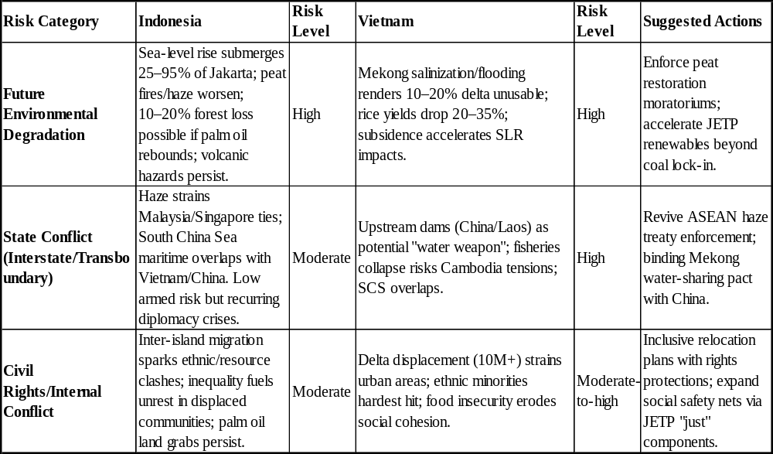
By mid-century, Southeast Asia's environmental future appears precarious under moderate-to-high emissions scenarios RCP4.5–8.5 (Yang, 2020), with Indonesia and Vietnam facing compounding threats from sea-level rise, extreme weather, and resource depletion. Indonesia risks losing up to 95% of northern Jakarta to submersion by 2050 (if sea-levels rise), displacing millions and straining inter-island migration systems amid ongoing peatland fires and haze events that could intensify diplomatic friction with Malaysia and Singapore. Deforestation for palm oil, despite recent slowdowns, may reverse under economic pressures, exacerbating biodiversity loss and carbon emissions. Vietnam's Mekong Delta, its agricultural heartland, could see 10–20% of land rendered unsuitable for rice by 2050 due to salinization and subsidence (Yang, 2020), with upstream dams in China and Laos reducing sediment flow by 50–90%, triggering food insecurity for 10+ million and potential cross-border migration to Cambodia.

Eco-conflict potential rises as environmental stressors intersect with geopolitics: transboundary haze in Indonesia and Mekong water weaponization risks for Vietnam could escalate low-level tensions into resource disputes, particularly amid South China Sea overlaps. Internal civil unrest from inequality-amplified displacement remains a wildcard, though both nations' JETP-funded transitions (Indonesia targeting net-zero by 2060, Vietnam renewables at 47% by 2030) provide mitigation pathways if funding solutions and local governance strengthens cooperation. Without robust international cooperation, the region faces a high likelihood of eco-conflicts by 2050, with Vietnam at greater interstate risk and Indonesia at greater risk of internal fragmentation.
Conclusion
Indonesia and Vietnam face intertwined eco-conflict vulnerabilities amplified by climate change. Vietnam's interstate risks and Indonesia's more internal and diplomatic ones, indicate that across population, poverty, resources, and environmental domains they remain at risk of eco-conflict. The final risk assessment forecasts a trajectory of high environmental degradation by 2050, driving moderate-to-high overall eco-conflict potential. Both nations have frameworks in place to safeguard their future but without prioritizing sustainability, local governmental enforcement and citizens willing to enact changes there is still a danger to their future. Pathways to avoid the econ-conflict exist through scaled JETP implementation, regional Mekong governance reforms, and funding increases. Prioritizing diplomacy, civil society empowerment, increasing NGO presence and binding transboundary agreements are essential to transform these vulnerabilities into a resilient Southeast Asia.

Bibliography
Al Hakim, Muhammad Firdaus, Brian Tony, Steven Chandra, Fanata Y. Nugraha, and Damar Nandiwardhana. 2025. “Mapping the Potential Co2 Source-Sinks for Carbon Capture Storage From Industry in Indonesia.” Scientific Contributions Oil and Gas 48 (1): 121–133.
Altman-Lupu, Michael, and Ben Swanton. 2024. “APOCALYPSE SOON?” https://the88project.org/wp-content/uploads/2024/08/Apocalypse-soon-Project88-FINAL.pdf.
Atkinson, Christopher L. 2014. “Deforestation and Transboundary Haze in Indonesia: Path Dependence and Elite Influences.” Environment and Urbanization Asia 5 (2): 253–267.
Birkmann, Joern, Emma Liwenga, Rajiv Pandey, Emily Boyd, Riyanti Djalante, François Gemenne, Walter Leal Filho, Patricia Pinho, Lindsay Stringer, and David Wrathall. 2022. “Poverty, Livelihoods and Sustainable Development.” In Impacts, Adaptation, and Vulnerability, 8.1–8.4. Cambridge: Cambridge University Press.
Climate Impacts Tracker. 2024. “Environmental Issues in Indonesia.” https://www.climateimpactstracker.com/environmental-issues-indonesia.
Colozza, David, Isabella Guo, Sri Wahyuni Sukotjo, Astrid Citra Padmita, Rene Gerard Galera, Endang Sulastri, Inti Wikanestri, and Mamadou Ndiaye. 2025. “The Impact of Climate Change on Child Nutrition in Indonesia: A Conceptual Framework and Scoping Review of the Available Evidence.” BMJ Paediatrics Open 9 (1): e002980. https://doi.org/10.1177/20488726221133387.
Gan, Christopher C. R., Rina S. Oktari, Hao X. Nguyen, et al. [full author list continues with Musumari, P. M., R. Kayano, and C. Chu]. 2021. “A Scoping Review of Climate-Related Disasters in China, Indonesia, and Vietnam: Disasters, Health Impacts, Vulnerable Populations, and Adaptation Measures.” International Journal of Disaster Risk Reduction 66: 102608. https://doi.org/10.1016/j.ijdrr.2021.102608.
Gatto, Andrea, and Elkhan Richard Sadik-Zada. 2025. “REDD+ in Indonesia: An Assessment of the International Environmental Program.” Environment, Development and Sustainability 27 (10): 24045–24060.
Giang, Pham Quy, and Rajendra Khanal. 2024. “What Next for Marine Ecosystem Management in Vietnam: Assessment of Coastal Economy, Climate Change, and Policy Implication.” Environmental Research Communications 6 (2): 025002.
Goodhand, Jonathan. 2001. “Violent Conflict, Poverty and Chronic Poverty.” Chronic Poverty Research Centre Working Paper 6.
Ha-Duong, Minh. 2025. “Power System Planning in the Energy Transition Era: The Case of Vietnam’s Power Development Plan 8.” Climate Policy 25 (4): 562–577.
Hoang, Quynh, Laure Pasquier-Doumer, and Camille Saint-Macary. 2022. “Ethnicity and Risk Sharing Network Formation: Evidence from Rural Vietnam.” The Journal of Development Studies 58 (2): 370–387. https://doi.org/10.1080/00220388.2021.1971648.
Hussein Do Miswa, Sabrina, and Fitri Kartiasih. 2025. “Nexus between Rural Poverty and Environmental Quality: Empirical Evidence from Indonesia.” Asia-Pacific Journal of Regional Science 9 (1): 57–81. https://doi.org/10.1007/s41685-024-00370-6.
Jazuli, Muhamad Rosyid, Kate Roll, and Yacob Mulugetta. 2024. “A Review of Indonesia’s JETP through the Dynamics of Its Policy Regime.” Global Policy 15 (5): 989–1006.
Oktari, Rina S., Febi Dwirahmadi, Connie Cai Ru Gan, Kristin Darundiyah, Pratomo Cahyo Nugroho, Arif Wibowo, and Cordia Chu. 2022. “Indonesia’s Climate-Related Disasters and Health Adaptation Policy in the Build-Up to COP26 and Beyond.” Sustainability 14 (2): 1006. https://doi.org/10.3390/su14021006.
Oppenheimer, Clive. 2003. “Climatic, Environmental and Human Consequences of the Largest Known Historic Eruption: Tambora Volcano (Indonesia) 1815.” Progress in Physical Geography 27 (2): 230–259.
O’Rourke, Ronald. 2015. Maritime Territorial and Exclusive Economic Zone (EEZ) Disputes Involving China: Issues for Congress. CRS Report No. R42784.
Purwono, Rudi, Wahyu Wisnu Wardana, Tri Haryanto, and M. Khoerul Mubin. 2021. “Poverty Dynamics in Indonesia: Empirical Evidence from Three Main Approaches.” World Development Perspectives 23: 100346.
Qiu, Jiahui, Sharon Seah, and Melinda Martinus. 2024. “Examining Climate Ambition Enhancement in ASEAN Countries’ Nationally Determined Contributions.” Environmental Development 49: 100945.
Rahmah, Adzra Vania, Wahyu Mei Lani, Lukman Nul Hakim Harahap, Riskiya Ruksah Ritonga, REH ULINA, Aris Halomoan Hasibuan, and Fitri Nadilla Marpaung. 2025. “Peran WALHI dalam Penanggulangan Bencana Nasional: Analisis Panduan dan Implementasi.” Triwikrama: Jurnal Ilmu Sosial 11 (7): 541–550.
Shahbaz, Muhammad, Ilham Haouas, and Thi Hong Van Hoang. 2019. “Economic Growth and Environmental Degradation in Vietnam: Is the Environmental Kuznets Curve a Complete Picture?” Emerging Markets Review 38: 197–218. https://doi.org/10.1016/j.ememar.2018.11.006.
Simorangkir, W. S., G. Golar, S. D. Massiri, S. Umar, and I. Rachman. 2024. “Indonesia’s Forestry and Other Land Use Net Sink 2030: How Preparedness Central Sulawesi to Start the Program?” IOP Conference Series: Earth and Environmental Science 1357 (1): 012001.
Sunanda, Wahri, M. Isnaeni Bambang Setyonegoro, and Sasongko Pramono Hadi. 2025. “Advancing the Carbon Pricing Framework in Indonesia: A Systematic Review of Policies, Challenges, and Global Lessons.” Results in Engineering: 107155.
Tarigan, Elieser. 2025. “Role of Solar Photovoltaic Energy in GHG Emission Reduction within Indonesia’s Long-Term Strategy for Low Carbon and Climate Resilience 2050.” International Journal of Energy Economics and Policy 15 (2): 421–428.
Tran, Nu Quy Linh, Huynh Thi Cam Hong Le, Cong Tuan Pham, Xuan Huong Nguyen, Ngoc Dang Tran, Tuyet-Hanh Thi Tran, Son Nghiem, et al. 2023. “Climate Change and Human Health in Vietnam: A Systematic Review and Additional Analyses on Current Impacts, Future Risk, and Adaptation.” The Lancet Regional Health – Western Pacific 40. https://doi.org/10.1016/j.lanwpc.2023.100932.
Tuan, Le Anh, and Suppakorn Chinvanno. 2011. “Climate Change in the Mekong River Delta and Key Concerns on Future Climate Threats.” In Environmental Change and Agricultural Sustainability in the Mekong Delta, 207–217. Dordrecht: Springer Netherlands.
Vo, Thang. 2018. “Household Vulnerability as Expected Poverty in Vietnam.” World Development 115: 1–14. https://doi.org/10.1016/j.worlddev.2018.10.006.
Vo, Thi Minh Hoang, Thi Phuong Linh Huynh, Peter Tamas, Marie-Noëlle Woillez, Etienne Espagne, Laurent Umans, Sepehr Eslami, Hong Quan Nguyen, and Philip SJ Minderhoud. 2025. “How Consistent Are Adaptation Strategies with Ongoing Climatic and Environmental Changes in the Vietnamese Mekong Delta: A Systematic Review.” Environmental Science & Policy 168: 104064.
World Bank. 2023. “Indonesia Overview: Development News, Research, Data.” https://www.worldbank.org/en/country/indonesia/overview.
Yang, Dongdong, Hua Zhang, and Jiangnan Li. 2020. “Changes in Anthropogenic PM and the Resulting Global Climate Effects under the RCP4.5 and RCP8.5 Scenarios by 2050.” Earth’s Future 8 (1): e2019EF001285.

